Electric Efficiency Function - PHEV-BEV - CGEA 1.3

Functional Description

The Electric Efficiency Function screen is used to inform the driver about average energy consumption (e.g. mi/Kwh) and estimated range per full charge based on the signals provided by the hybrid powertrain controls.

The Electric Efficiency Function correlates the inputs of VehElEffAvg_No_Dsply , RngPerChrgAvg_L_Dsply and Display_Units_MC to inform the driver about Average energy consumption and range per full charge.

There are different display formats based on program graphics to show Electric Efficiency and Range per Full charge. In this update, Bar graph and Push-Pull graph is added to display Electric efficiency and Range per Full charge. Graphics requirements need to be followed to find applicable graphics.

Interfaces

Interface Context Diagram (I/O Block Diagram)
Electric Efficiency Function Context Diagram

Inputs

IR-REQ-320013/A-INTERNAL:
  - Operational_Mode
  - Display_Units_MC

MUX messages on the CAN Bus

CAN Input Signals

SIG-REQ-320001/A-VehElEffAvg_No_Dsply

Signal Name | Size (bits) | Detail | Units | Res. | Offset | State  Encoded | Min | Max
VehElEffAvg_No_Dsply | 7 |  | Wh/km | 10 | -100 |  | -100 (0x0) | 1150  (0x7D)
 |  | NoDataExists |  |  |  | 0x7E
 |  | Faulty |  |  |  | 0x7F

SIG-REQ-320002/A-RngPerChrgAvg_L_Dsply

Signal Name | Size (bits) | Detail | Units | Res. | Offset | State  Encoded | Min | Max
RngPerChrgAvg_L_Dsply | 12 |  | km | 0.1 | 0 |  | 0 (0x0) | 409.3 (0xFFD)
 |  | NoDataExists |  |  |  | 0xFFE
 |  | Faulty |  |  |  | 0xFFF

IR-REQ-320019/A-Outputs
- EEF_AvgEnergy
- EEF_Rngfchrg

Function/Performance

F-REQ-320020/A-Operational Modes

Mode | Differentiating Vehicle Conditions
Sleep Mode | Electric Efficiency Function Off
Limited Mode | Electric Efficiency Function Off
Normal Mode | Electric Efficiency Function Functioning
Crank Mode | Electric Efficiency Function Functioning

Voltage Levels
Refer to Cluster Features table located in Operational Modes and Voltage Range Strategies Section in this SPSS.

Human-Machine Interface

Visual

Indicator Graphics / Display Format
Electric Efficiency screen layout
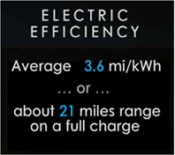

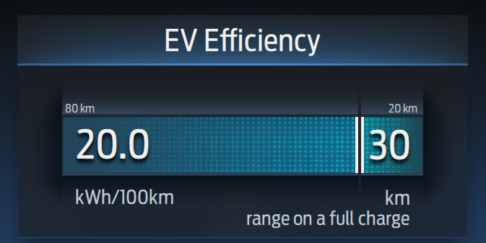
Push Pull Electric Efficiency Example from CD542 and P702 BEV

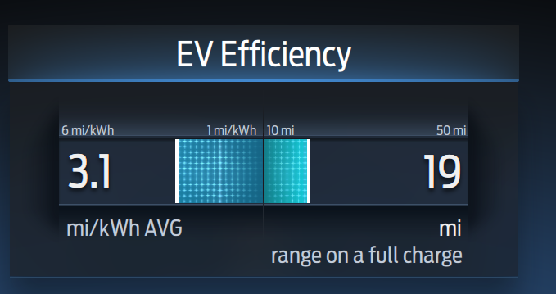
Bar Graph Electric Efficiency Example from CD542 and P702 BEV

Above are example graphics.
Actual graphics are to be provided by Ford HMI or Studio and approved by the DI Application for each program.

Indicator Color Coordinates
Reference Ford HMI or Studio Wallpaper files for the specific program.

Indicator Characteristics
Reference Ford HMI or Studio Wallpaper files for the specific program.

Audio
None

Switch Control Logic
None

System Accuracy

PFM-REQ-320014/A-State Change Display Response Time
- Within a 100msec of receiving a message/input that results in a change of state the cluster will update the display to the proper status.

PFM-REQ-320015/A-KM to Miles Conversion Constant
- Shall use kilometer to miles conversion constant of 1/1.609344.

Operation: Performance and Functional

Subsystem Algorithm Flowchart / State Diagram

F-REQ-320003/B-Electric Efficiency Graphic Components
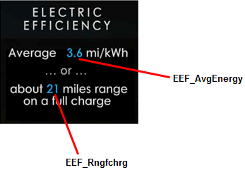

Push Pull Electric Efficiency Example from CD542 and P702 BEV

Bar Graph Electric Efficiency Example from CD542 and P702 BEV

F-REQ-320004/A-Flowchart for CAN Diagnostic Configuration Routine

F-REQ-320005/D-Electric Efficiency Function Routine

F-REQ-379995/B-Electric Efficiency Display Selection between Bar Graph and Push-Pull Graph

Operation Description (supports algorithm flowchart /state diagram)

F-REQ-320007/A-Electric Efficiency Function
The Electric Efficiency function shall include an indication of average energy consumption and rated range per full charge.

F-REQ-320008/A-Average Indicator Number
The average energy consumption and range per full charge are displayed as an average indicator, number. If a number is shown on the display, it shall display range 0.0 to 99.9, with no leading zero (except the one before decimal point)

F-REQ-320010/A-Electric Efficiency Information Value during Key Off
During key off, the information displayed for Electric Efficiency shall not be updated (i.e. the key off displays are static, even if the CAN signal values change)

F-REQ-320011/A-Blank Display Condition for VehElEffAvg_No_Dsply
In case of signal VehElEffAvg_No_Dsply ,if values from 0x0 through 0xA (i.e. 0 to -100), display blank for their values.

F-REQ-320012/C-Display for Missing\Invalid Signal
In case of missing or invalid signal or if the value is out of range for signals VehElEffAvg_No_Dsply, RngPerChrgAvg_L_Dsply, display dashes for their values.

F-REQ-380031/B-Push-Pull Graph
- If the Range Per Full Charge signal is missing or invalid, the IPC shall replace it with dashes and the graph needle shall be at the maximum right position.
- If the Electric Efficiency signal is missing or invalid, the IPC shall replace the Electric Efficiency number with dashes. There is no fill or graph needle for Electric Efficiency.
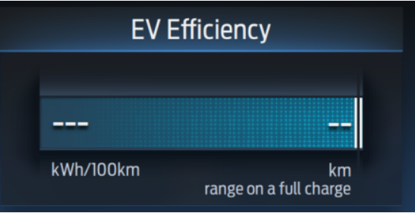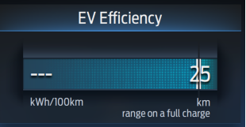

F-REQ-380039/B-Bar Graph
- If the Range Per Full Charge signal is missing or invalid, the IPC shall replace it with dashes and the graph needle shall be at the maximum right position (empty gauge).
- If the Electric Efficiency signal is missing or invalid, the IPC shall replace the Electric Efficiency number with dashes and the graph needle shall be at the maximum left position (empty gauge).

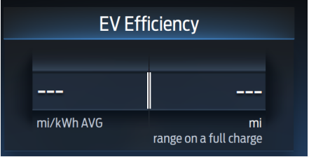

F-REQ-380055/B-Electric Efficiency/Range - Bar Graph Display Logic

F-REQ-380056/B-Range Per Full charge display logic - Bar Graph
The range per full charge graph shall be a function of the Range Per Full Charge where:
  - Range Per Full Charge <= 10 mi or 20 km, the needle will be pushed to the maximum left position
  - Range Per Full Charge >= 50mi or 80 km, the needle will be pushed to the maximum right position.
  - The graph will be linearly interpolated for any value between 20km and 80km when units are in km/kWh and 10mi and 50mi when units are in mi/kwh.

F-REQ-380058/B-Electric Efficiency display logic - Bar Graph
The electric efficiency graph shall be a function of the Electric Efficiency where:
- Electric Efficiency <= 1 km/kWh or 1mi/kWh, the needle will be pushed to the maximum right position
- Electric Efficiency >= 10km/kWh or 6 mi/kWh, the needle will be pushed to the maximum left position.
- The graph will be linearly interpolated for any value between 1 km/kWh and 10km/kWh when units are in km/kWh and 1mi/kWh and 6 mi/kWh when units are in mi/kWh

F-REQ-380059/B-Display Function
The Electric Efficiency shall be displayed with one decimal point. The Range Per Full Charge Number shall use standard ceiling function as per previous logic.

F-REQ-380060/B-Electric Efficiency/Range Push-Pull graph display

F-REQ-380061/B-Range Per Full charge display logic- Push-Pull Graph
- The graph shall be a function of the Range Per Full Charge where:
  - Range Per Full Charge <= 20 km, the needle will be pushed to the maximum right position
  - Range Per Full Charge >=80 km, the needle will be pushed to the maximum left position.
  - The graph shall be linearly interpolated for any value between 20km and 80km

F-REQ-380062/B-Electric Efficiency display logic - Push-Pull Graph
Electric Efficiency will be shown as Numerical value and there is no gauge fill for electric efficiency. Electric efficiency will be shown with single digit decimal value.

F-REQ-380063/B-Display Function
The Electric Efficiency shall be displayed with one decimal point. The Range Per Full Charge Number shall use standard ceiling function as per previous logic.

FS-REQ-320025/A-Function Safety Classification (EMC)
Class B

NVM-REQ-320016/A-Memory Storage

Parameter Name | Description | Value at Battery connect | Value at  Module Wake-up
VehElEffAvg_No_Dsply | CAN Input for Avg energy consumption per unit distance | 0 | Do Not Init
RngPerChrgAvg_L_Dsply | CAN Input for estimated average electric range per full charge. | 0 | Do Not Init
EEF_AvgEnergy | Output of Avg energy consumption per unit distance. Parameter is to be stored in battery backed memory | 0 | Do Not Init
EEF_Rngfchrg | Output of Avg electric range per full charge. Parameter is to be stored in battery backed memory | 0 | Do Not Init
Display_Units_MC | Input to this routine that controls display indicating units to the driver (i.e. when English: miles, mpg; when Metric: km, L/100 km, km/L). Parameter is to be stored in Battery Backed RAM. | Used Stored Value of Display_Unit_  Selection_Cfg  (See Display Unit Selection Control Function STSS) | Do Not Init
Operational_Mode | Input to this routine that is a 4 State indicator for cluster operational mode | Limited | Limited or Normal or Crank

Prove Out
Not applicable.

Reconfigurable Telltale
Not applicable.

Message Center Msg
Not applicable.

Error Handling

Missing Message Strategy
The signals will be declared missing as per the Diagnostics section of this SPSS.

DTCs states and history will be determined as per the Diagnostics section of this SPSS.

Invalid Data Strategy
The signals will be declared invalid as per the Diagnostics Section of this SPSS.

DTC states and history will be determined as per the Diagnostics Section of this SPSS.

Diagnostics

Self Test
None.

Engineering Test Mode
Reference section “Dealer / Engineering Test Mode (ETM)”.

Part II Performance

DTC-REQ-320017/A-Supported Diagnostic Trouble Codes (DTCs)

DTC | Description
C29300 | Lost Communication with Hybrid/EV Powertrain Control Module

DCR-REQ-320018/A-DID DExx

Block  Num | Block Description | Byte(s) | Bits | State: Description | "0" | "1" | Default | Comments/  Information
$01 | Option Content (B&A) |  | 2 | PT Hybrid  0x0 = Non-Hybrid  0x1 = BEV  0x2 = FHEV  0x3 = PHEV |  |  | 0x0 | Default from cluster plant to be 0x0 if cluster can be used on a Non-Hybrid.

Reference Specification
IS-0344 GENERAL REQUIREMENTS (MSGCENTR)
IS-0379 NORTH AMERICAN WARNINGS AND INDICATORS STRATEGY

- Plug In Energy Economy Gauge – CGEA 1.3 STSS
- Operational Modes and Voltage Range Strategies .doc
- Display Unit Selection Control Function .doc
- Warning - PHEV_FHEV_Ready STSS

Revision History
SPSS Module Revision History

Revision Level | Name | Change Description | Date
1.0 | P Khot | Initial Release based upon request from EPE team for Electric Efficiency Information for PHEV vehicles. | 2/20/2017
2.0 | H Sharma | Updates based upon request from EPE team(Dale Gilman) for Electric Efficiency Information for PHEV vehicles.  - Graphics updated in section 1.3.3.1.1, figure 1.3 “Electric Efficiency Graphic Components” and Figure 1.4 Electric Efficiency Function Routine is also updated.  - Electric Efficiency Units updated from Wh/mi to mi/kWh  - To accommodate the conversion formulas in Figure 1.4 “Electric Efficiency Function Routine” is also updated | 08/24/2017
2.1  &  2.2 | H. Sharma  &  A.Mishra | - These updates are based in supplier Q&A :  - Functional Description updated to fix unit type and to remove HPCM Wakeup Delay timer.  - Context Diagram updated  - Operational description updated to clarify number of digits to display.  - Figure 1.4 Electric Efficiency Function Routine updated to add kwh/100km metric unit.  - Invalid Data DTC logging removed.  - Initial VSEM RM Release | 07/16/2018
3.0 | H. Sharma | This request came from EPE team (Charbel Bouery) and approved for STSS update on 02/05/2020. This change was initially requested for CD542 and P702 BEV but never implemented in these two programs for different reasons. Next future program insight for this update is Cx746.  DICC #488  Lead program: May be Cx746  Changes are marked in Yellow color.  - Now this STSS is also applicable to BEV’s, name and flowchart updated.  - Section 1.1 updated to add brief description of new HMI.  - Section 1.3.3.1.1 Indicator Graphics / Display format is updated to add new HMI examples.  Section 1.3.5.1.1 F-REQ-320003/B-Electric Efficiency Graphic Components is updated to add new graphics.  Section 1.3.5.1.3 F-REQ-320005/C-Electric Efficiency Function Routine is updated to add BEV applicability  Section 1.3.5.2.5 F-REQ-320012/B-Display for Missing\Invalid Signal is updated to explain push-pull graph behavior in missing message condition.  Section 1.3.5.2.5 F-REQ-320012/B-Display for Missing\Invalid Signal is updated to explain missing message behavior in new graphics.  - New sections 1.3.5.2.6 and 1.3.5.2.7 are added to explain core logic for new HMI. | 10/22/2020

